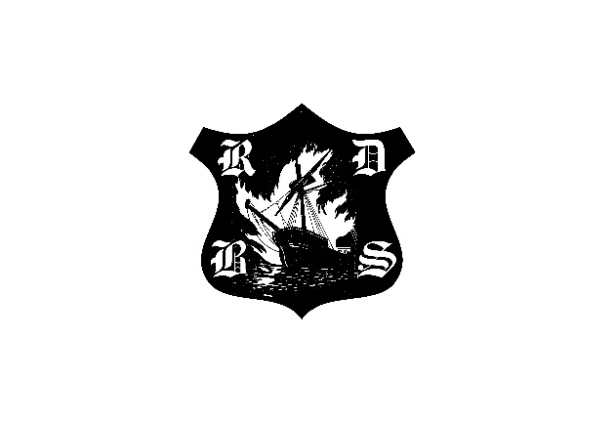
THE RYE & DISTRICT BONFIRE SOCIETY

Formed to benefit the people who live in and around the Town of Rye

Membership Renewal 2015

Send to: Neale East, RDBS Membership Secretary,
4 Faraday House, The Mint, RYE, East Sussex, TN31 7EW

Total Amount Enclosed £……..

( )tick Adult Membership £5 each (£25 each after 1st September 2015)

Name ………………………………..
Name ………………………………..

( )tick Junior Membership (without parents and age under 18) £1 each

Name: ………………………………. DOB…….….

( )tick Child Membership (with parents and age under 18) Free

Name: ………………………………. DOB…….….
Name: ………………………………. DOB…….….
Name: ………………………………. DOB…….….

Address:………………………………………………………………………………..

Post Code:…………

Telephone:……………………………….. E-Mail:…………………………………

Area(s) of Interest:………………………………………………………………………

( )tick I agree to abide by the published Code of Conduct of RDBS

Signed: …………………………………

Directors: A.Tollett – P.Carey – F Warren Secretary: R,Kirk Treasurer: I Foster
Rye & District Bonfire Society is a company limited by guarantee
Company Reg No: 466575 Registered Office: 8 High Street, Rye, East Sussex TN31 7JH

