Frederick James O’Brien ISM

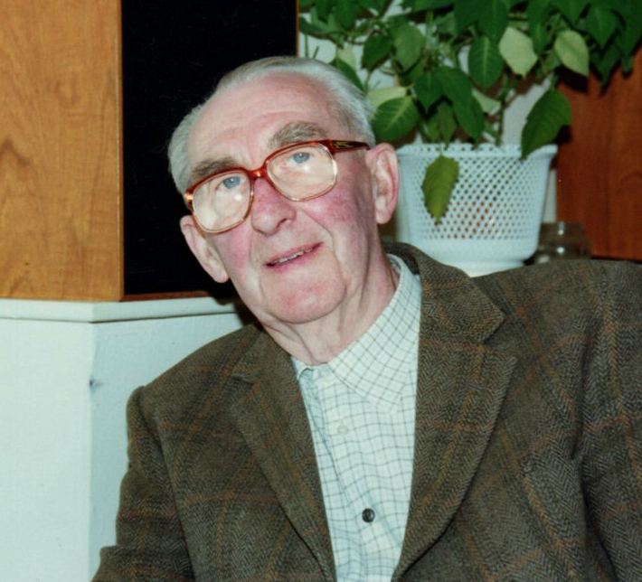

Fred was born on 10 October 1909 in Gillingham, Kent.

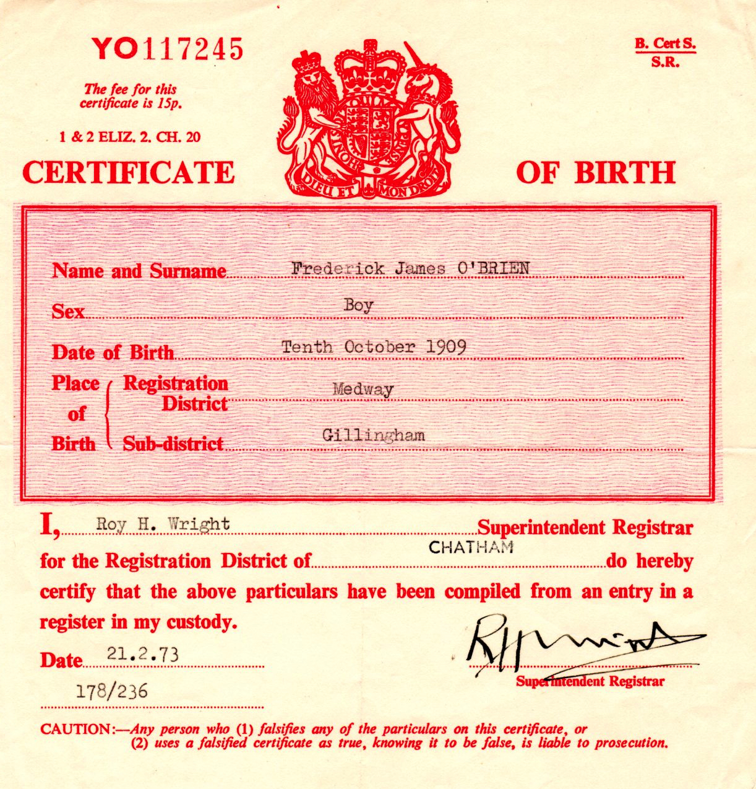

In 1924, he started work at the Post Office in Aldershot, Hampshire as a Telegraph Boy and remained with the Post Office for over 45 years retiring as Supervisor.

Whilst both working at the Post Officer Fred met Norah Hester Johnstone, they fell in love, and in 1935 married in Aldershot and lived at 117 Newport Road (later re-named 97 Newport Road after new houses were built opposite) for the rest of their lives.

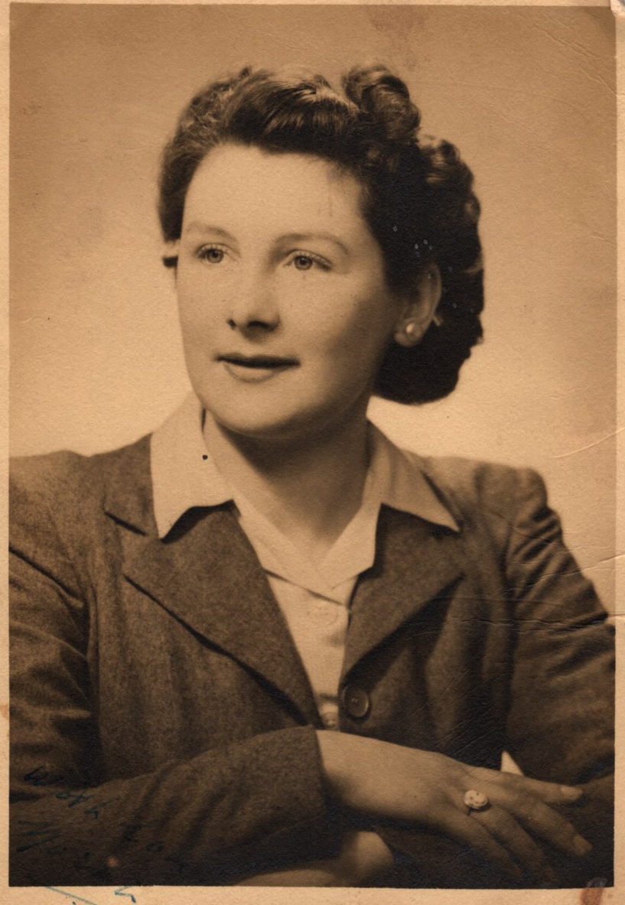

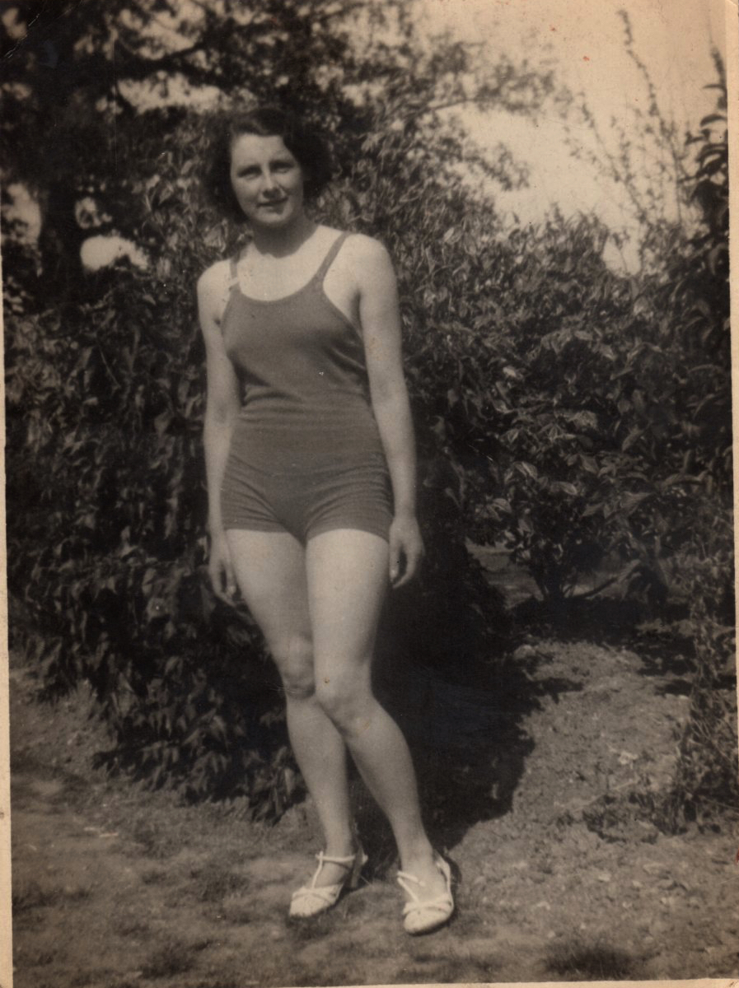
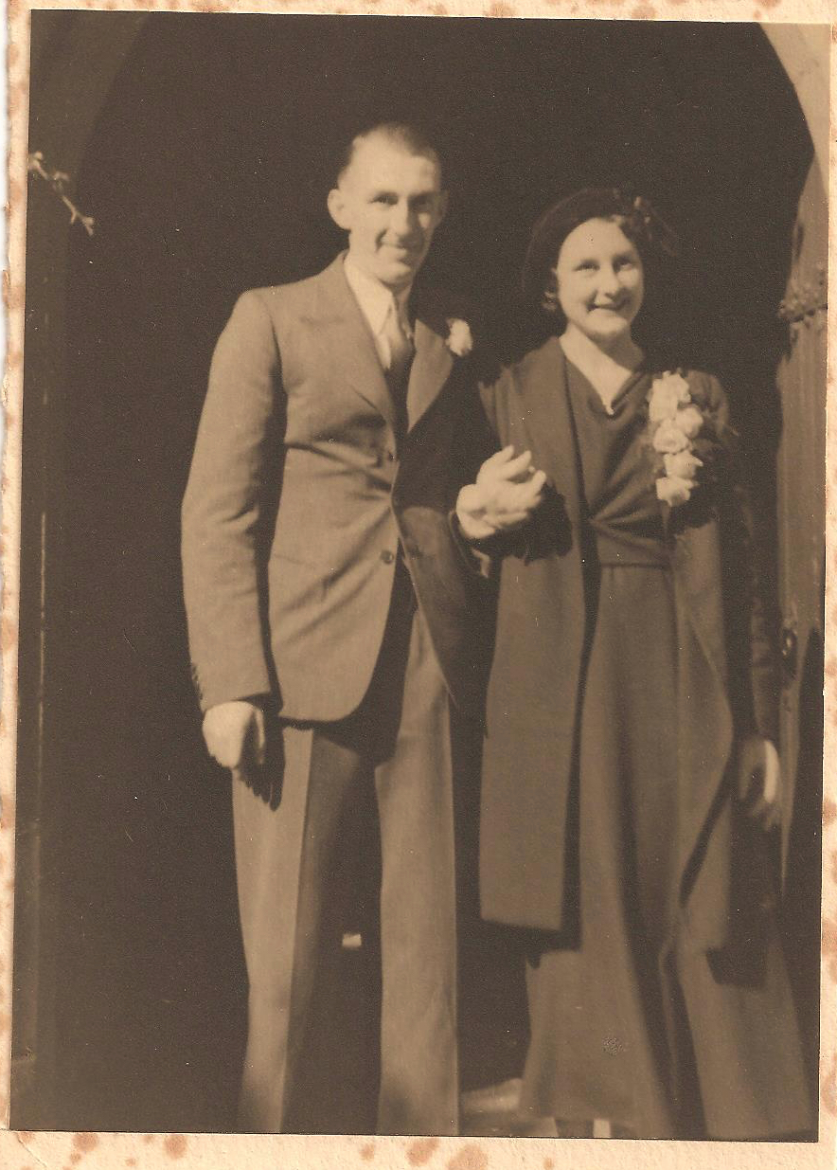

Norah & Fred on their Wedding Day

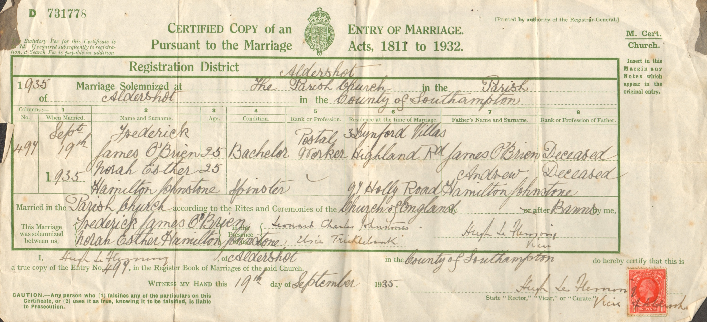
In 1941 Fred enlisted into the RAF Voluntary Reserve as a wireless operator.

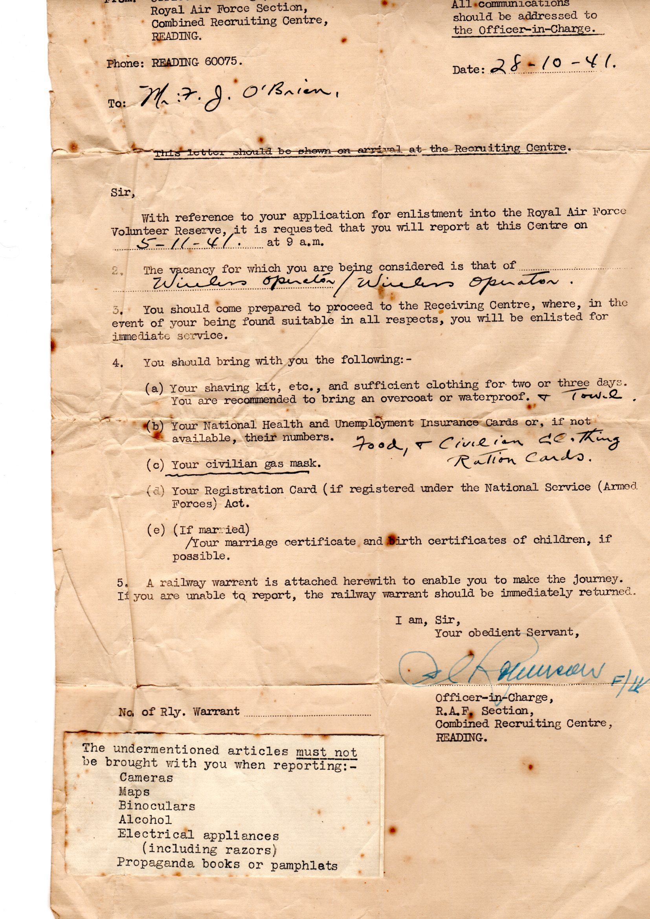

Fred was soon posted to the Cocos Islands in the Indian Ocean where he served with Section E, 129 Staging Post in the photographic reconnaissance unit.

129 was part of Operation ‘Pharos’ to develop the Cocos Islands as a staging post with facilities to handle 500 multi-engine aircraft per month. The unit arrived at the Cocos Islands on 7 April 1945, and left in April 1946.
The Cocos (Keeling) Islands consist of two flat, low-lying coral atolls with an area of 14.2 square kilometres (5.5 sqm), 26 kilometres (16m) of coastline, a highest elevation of 5 metres (16ft) and thickly covered with coconut palms and other vegetation. The climate is pleasant, moderated by the southeast trade winds for about nine months of the year and with moderate rainfall. Tropical cyclones may occur in the early months of the year.
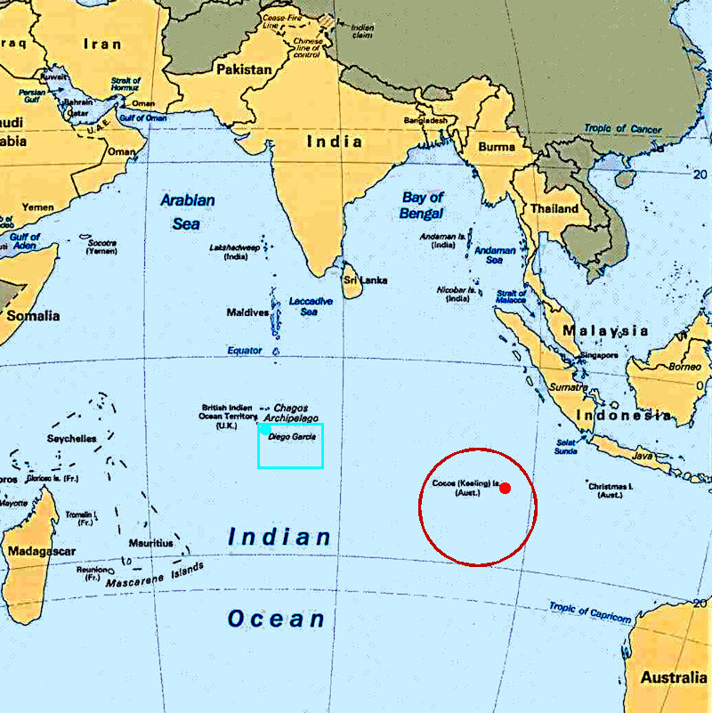
North Keeling Island is an atoll consisting of just one C-shaped island, a nearly closed atoll ring with a small opening into the lagoon, about 50 metres (160ft) wide, on the east side. The island measures 1.1 square kilometres (270 acres) in land area and is uninhabited. The lagoon is about 0.5 square kilometres (120 acres). North Keeling Island and the surrounding sea to 1.5 km (0.93m) from shore form the Pulu Keeling National Park, established on 12 December 1995. It is home to the only surviving population of the endemic, and endangered, Cocos Buff-banded Rail.
South Keeling Islands is an atoll consisting of 24 individual islets forming an incomplete atoll ring, with a total land area of 13.1 square kilometres (5.1 sqm). Only Home Island and West Island are populated. The Cocos Malays maintain weekend shacks, referred to as pondoks, on most of the larger islands.
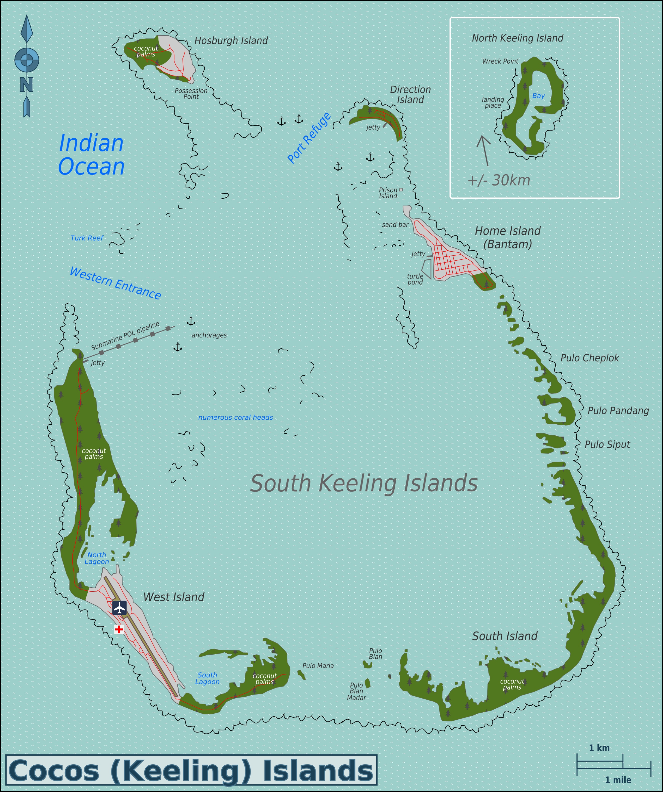
In 1901, a telegraph cable station was established on Direction Island. Undersea cables went to Rodrigues, Mauritius, Batavia, Java and Fremantle, Western Australia. In 1910, a wireless station was established to communicate with passing ships. The cable station ceased operation in 1966
During World War II, the cable station was once again a vital link. The Cocos were valuable for direction finding by the Y service, the worldwide intelligence system used during the war.
Allied planners noted that the islands might be seized as an airfield for German planes and as a base for commerce raiders operating in the Indian Ocean. Following Japan's entry into the war, Japanese forces occupied neighbouring islands. To avoid drawing their attention to the Cocos cable station and its islands' garrison, the seaplane anchorage between Direction and Horsburgh islands was not used. Radio transmitters were also kept silent, except in emergencies.
After the Fall of Singapore in 1942, the islands were administered from Ceylon (Sri Lanka), and West and Direction Islands were placed under Allied military administration. The islands' garrison initially consisted of a platoon from the British Army's King's African Rifles, located on Horsburgh Island, with two 6-inch (152.4 mm) guns to cover the anchorage. The local inhabitants all lived on Home Island. Despite the importance of the islands as a communication centre, the Japanese made no attempt either to raid or to occupy them and contented themselves with sending over a reconnaissance aircraft about once a month.
On the night of 8–9 May 1942, 15 members of the garrison, from the Ceylon Defence Force, mutinied under the leadership of Gratien Fernando. The mutineers were said to have been provoked by the attitude of their British officers and were also supposedly inspired by anti-imperialist beliefs. They attempted to take control of the gun battery on the islands. The Cocos Islands Mutiny was crushed, but the mutineers killed one non-mutinous soldier and wounded one officer. Seven of the mutineers were sentenced to death at a trial that was later alleged to have been improperly conducted. Four of the sentences were commuted, but three men were executed, including Fernando. These were to be the only British Commonwealth soldiers executed for mutiny during the Second World War.
On 25 December 1942, the Japanese submarine I-166 bombarded the islands but caused no damage.
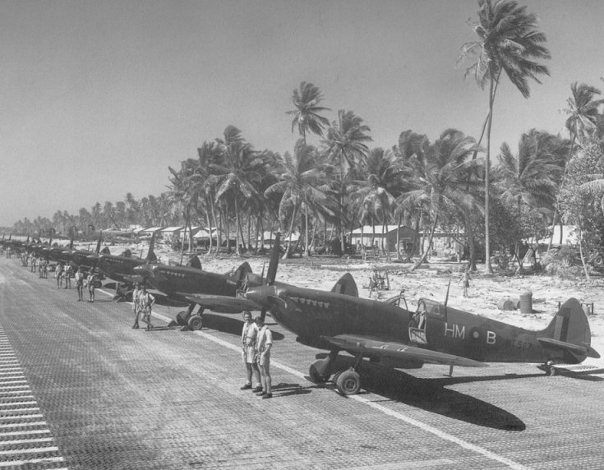
Spitfire Mk VIIIs of No. 136 Squadron RAF
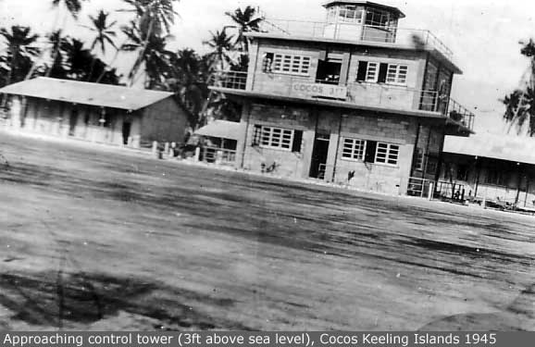
Later in the war, two airstrips were built, and three bomber squadrons were moved to the islands to conduct raids against Japanese targets in South East Asia and to provide support during the planned reinvasion of Malaya and re-conquest of Singapore. The first aircraft to arrive were Supermarine Spitfire Mk VIIIs of No. 136 Squadron RAF. They included some Liberator bombers from No. 321 (Netherlands) Squadron RAF (members of exiled Dutch forces serving with the Royal Air Force), which were also stationed on the islands. When in July 1945 No. 99 and No. 356 RAF squadrons arrived on West Island, they brought with them a daily newspaper called Atoll which contained news of what was happening in the outside world. Run by airmen in their off-duty hours, it achieved fame when dropped by Liberator bombers on POW camps over the heads of the Japanese guards.
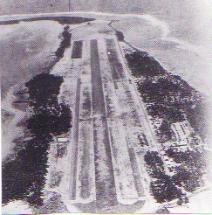
Cocos Airstrip 1945
In 1946, the administration of the islands reverted to Singapore and it became part of the Colony of Singapore.
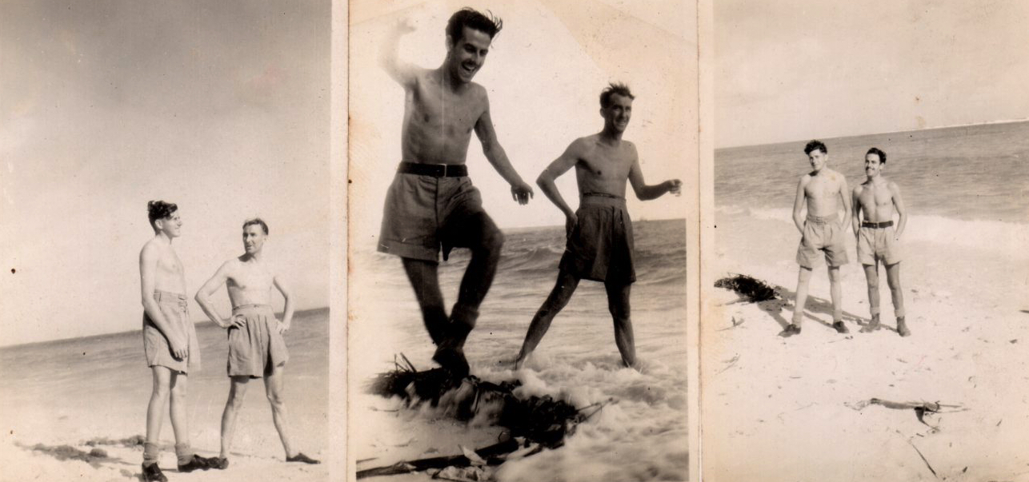
Life on Cocos was not all work..
Before leaving the Island in 1945 Fred was mentioned in a letter from the Royal Australian Air Force in appreciation of Fred and his comrades for their contribution:
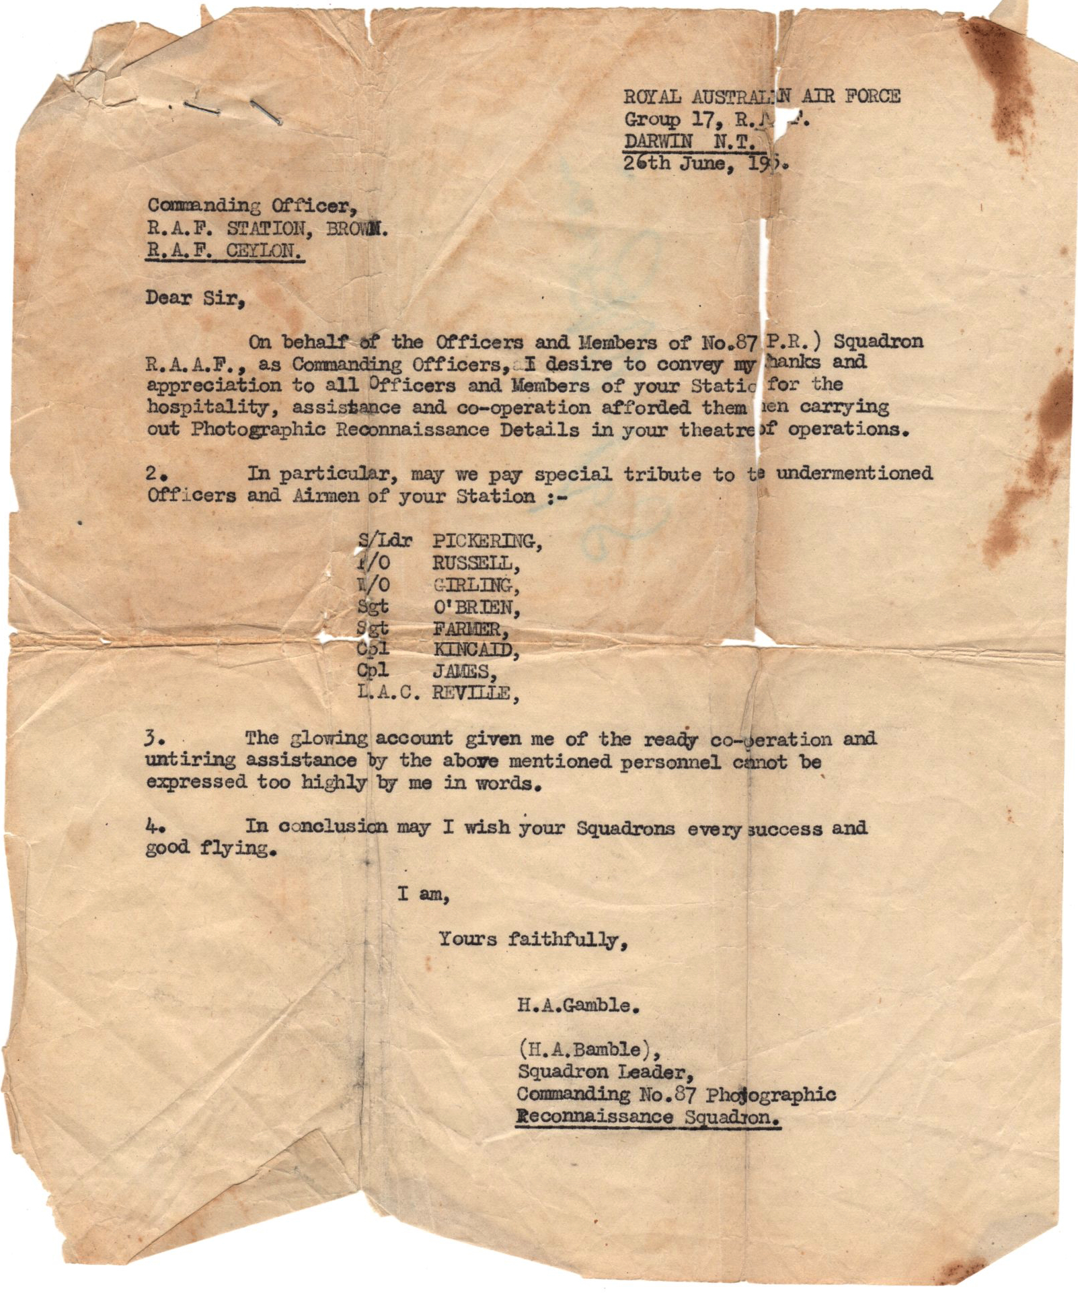

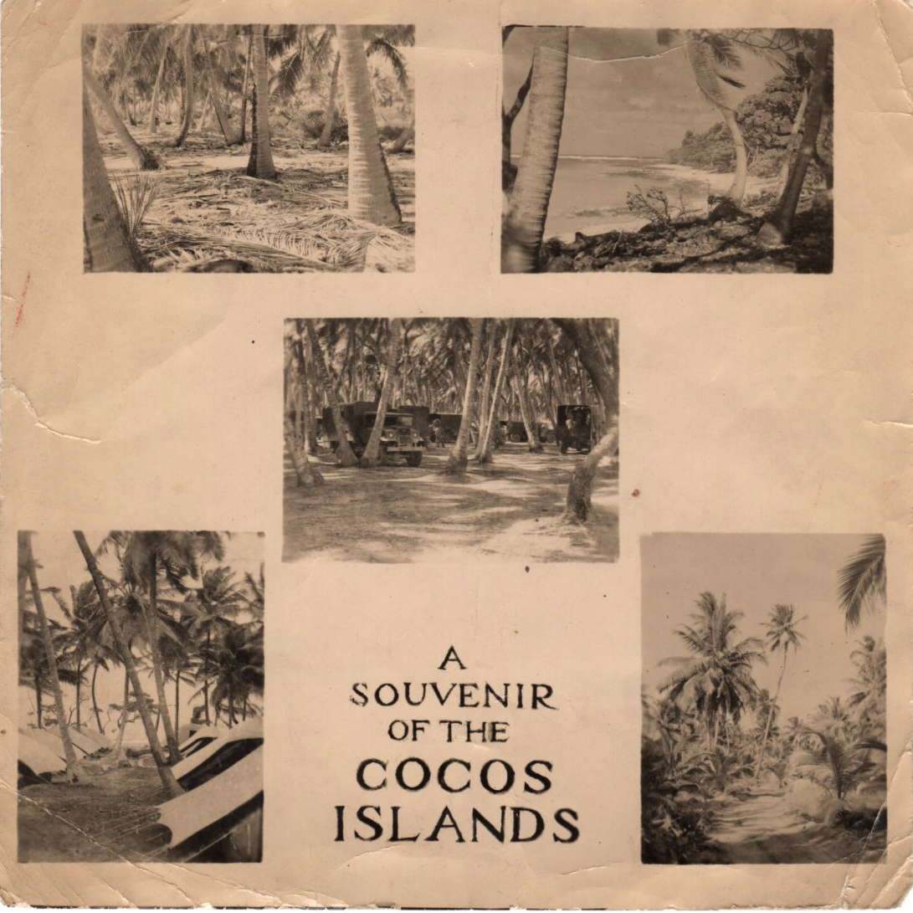

Fred wrote a ‘bluey’ to Norah from the Cocos Islands in November 1945….
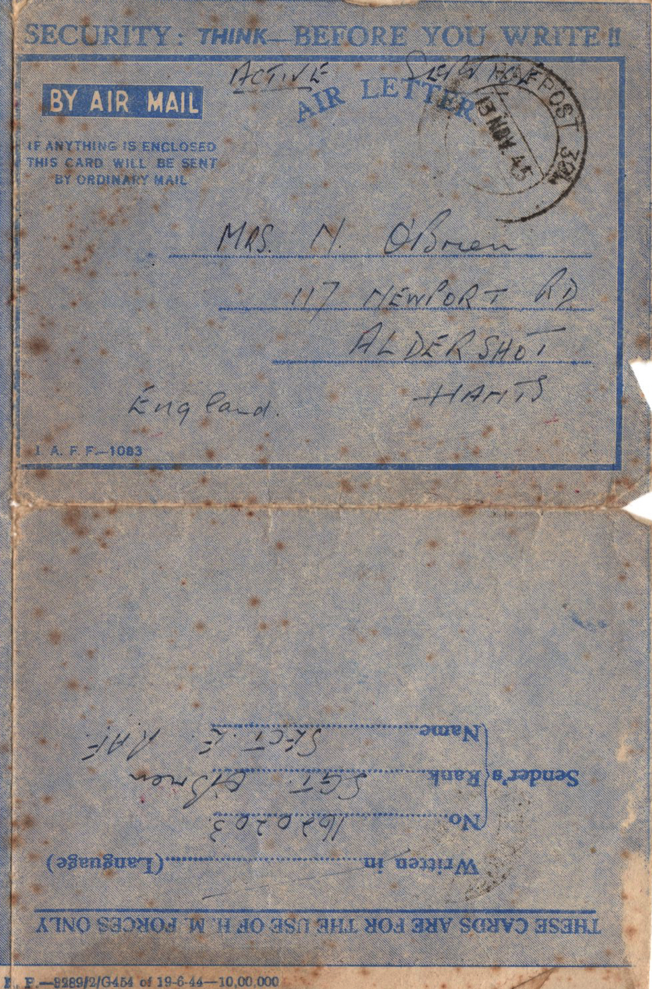

The ubiquitous ‘Bluey’ has been an invaluable moral boosting service to armed forces personal whilst on active service, they are sent via the BFPO (British Forces Post Office) which can trace its history back to 1799 when the office of Army Postmaster was established.
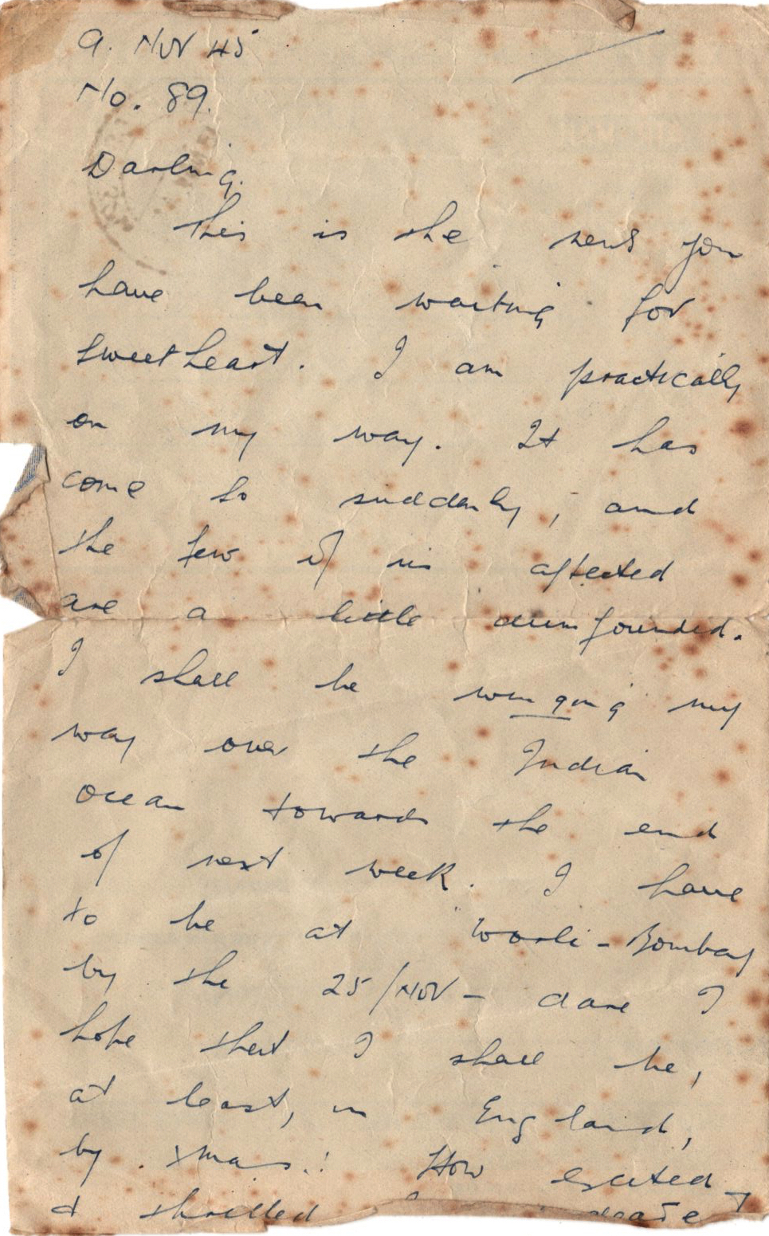

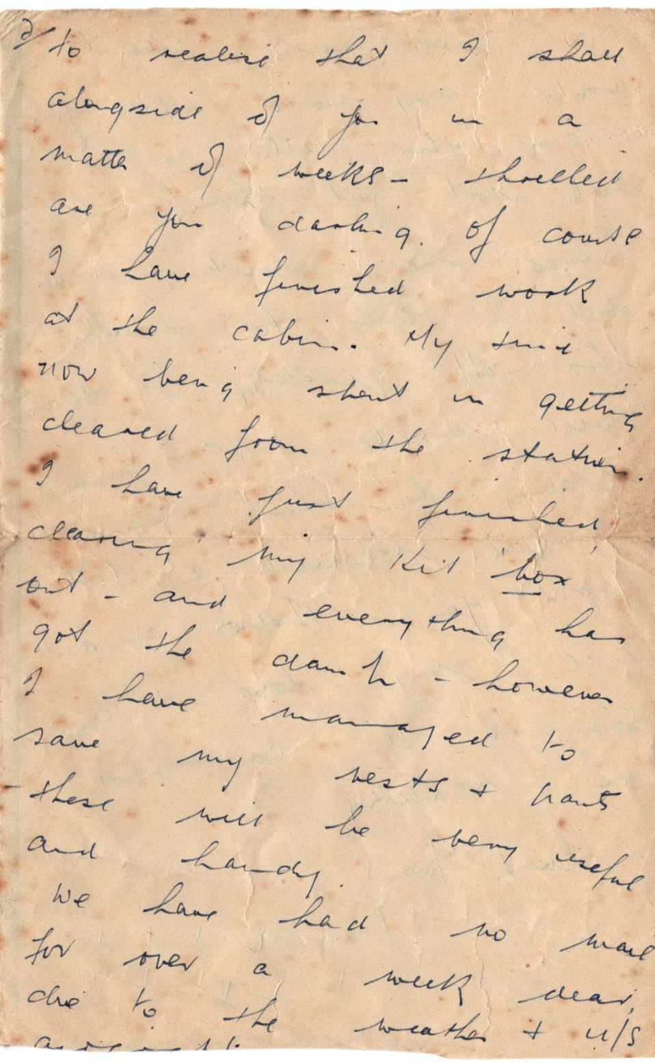
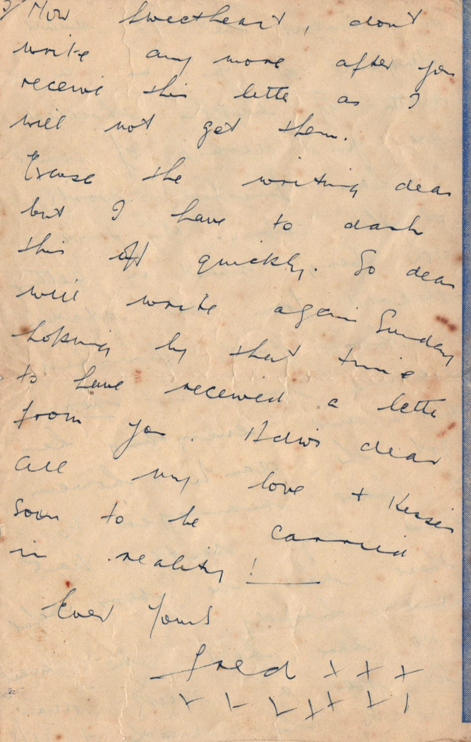

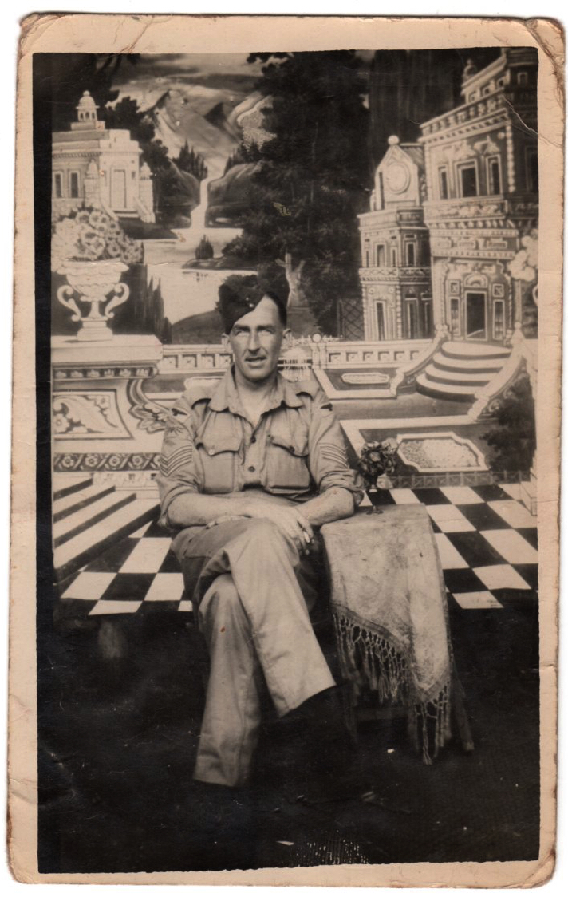
Sergeant Frederick James O’Brien RAF (VR)
Picture taken at Worli, Bombay on R&R in November 1945 – on the reverse Fred writes ‘a trifle dishevelled dear, feeling the heat’!!
On 04 December 1945 Fred finally set sail from Worli, Bombay, on ‘HMS Bermuda’ (the same ship as he arrived on) to return home via Aden, Port Said, Gibraltar and finally landing in Liverpool. Fred noted in a letter to Norah that he hoped ‘that the grub has improved!’
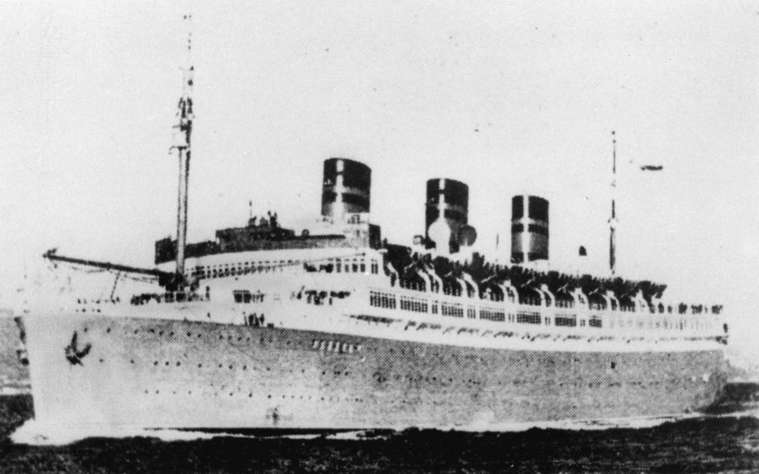
HMS Queen of Bermuda
After landing at Liverpool Fred was sent to RAF Hednesford where it is likely he was finally demobbed; Fred sent Norah a telegram from Hednesford to confirm that he will be home soon..
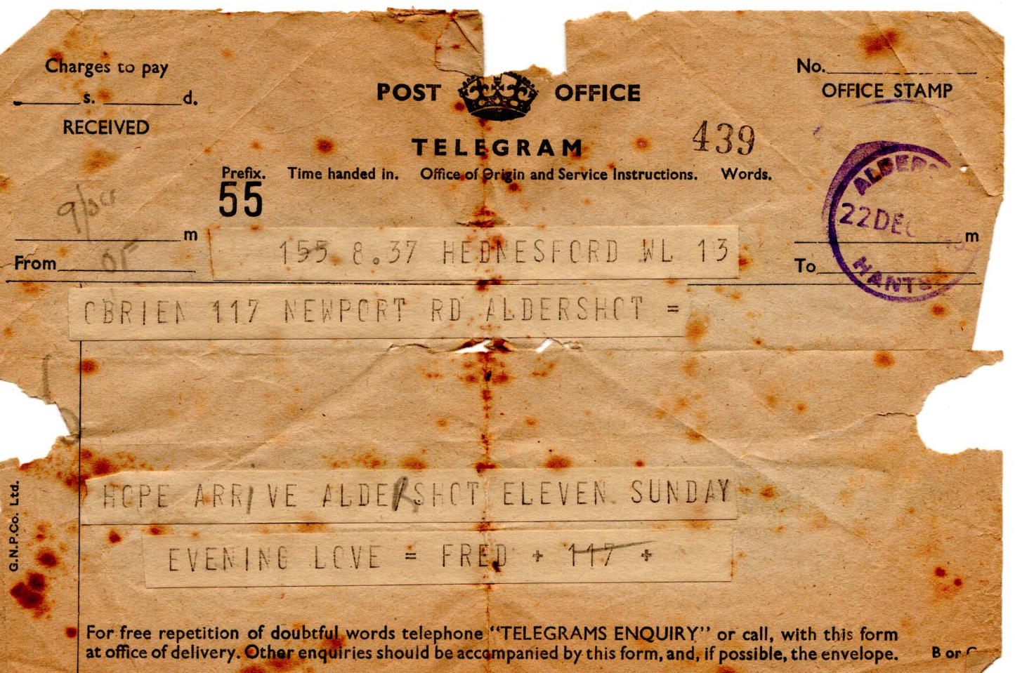
Fred then returned to 117 Newport Road and worked at the Post Office in Aldershot until his retirement in 1969.

On his retirement, Fred was awarded the Imperial Service Medal for over 45 years’ service to the Post Office.

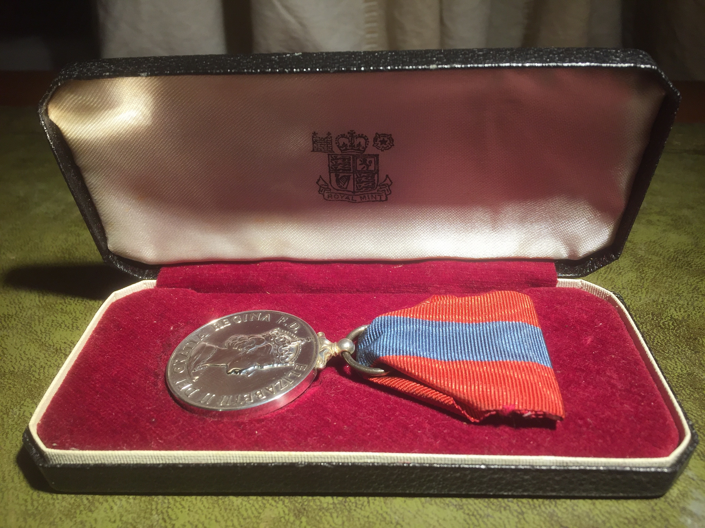

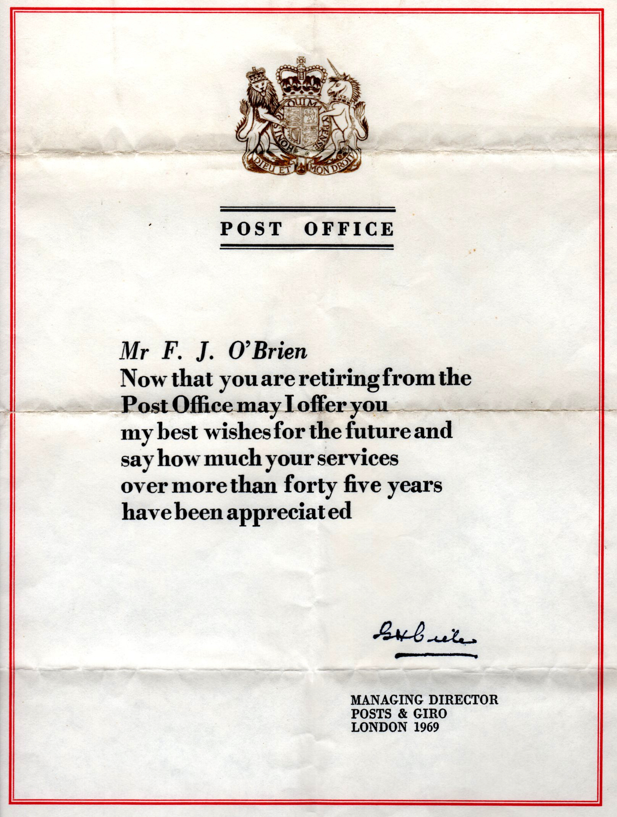

The Imperial Service Medal (ISM) was awarded to selected long-standing Post Office employees upon retirement. The award of the ISM was recorded on employees' pension records.

The ISM was introduced in 1902 as a way of formally recognising the achievements of civil servants working in the United Kingdom and overseas. It was awarded to manual grade employees of the civil service with a good service record. The ISM was introduced along with another award, the Imperial Service Order (ISO), which was granted to administrative and clerical grades of the civil service.

Until 1969 the Post Office was a government department. This meant that Post Office employees were recognised as civil servants and could be nominated for the medal. To be eligible, civil servants had to be established members of staff with at least 25 years’ pensionable service, or 16 years if serving in “unhealthy climates abroad”. Sub-office postmasters and postmistresses could not be nominated, although postmen working from sub-offices were eligible.

Length of service was not the only criterion on which nomination were based, and the Post Office made it clear that awards were not a matter of right. Employees also had to show interest and zeal in their work, and had to work in such a way that did not require constant supervision. They also needed an unblemished official conduct record, or, as it was put in official terms, to have given “long, zealous, and meritorious service”.

The responsibility for nominating staff fell to Head Postmasters. Guidelines on what was and what was not considered to be zealous and meritorious service were set out in a regularly issued publication, the Rules for Head Postmaster.

Medals were awarded in a local ceremony, and the presentations were usually made by the Head Postmasters with regional senior management, colleagues, friends and family attending. Unlike the ISOs, which were awarded twice a year, ISMs were awarded monthly. The name, job title, rank and location of recipients was published in The London Gazette, one of the official journals of the British government.

The first medals had a central silver medallion with the Royal Cypher in blue enamel on the face, surrounded by the inscription ‘For Faithful Service’ in blue enamel. The medallion was surrounded by a seven-pointed star surmounted by the Imperial Crown. The medal awarded to women from 1906 had the same central medallion design as the men’s, but it was surrounded by a wreath of laurel, in bronze, surmounted by the Imperial Crown in silver.

In 1920 the design of the medal was changed to that of a silver circular medal for both men and women. The front face was the ‘civil head’ of George V; the reverse depicted a finely sculptured male figure gazing out across the sea towards the setting sun. It symbolised rest after labour, and the words ‘For Faithful Service’ were written below. The ‘crowned head’ of George V replaced the uncrowned ‘civil head’ in 1931, and subsequent monarchs have been indicated by ‘crowned effigies’.

The medals were worn suspended from the left breast or shoulder by a ribbon watered red with a central light blue stripe. Women usually wore the ribbon tied into a bow.

Both Norah and Fred volunteered to help run functions at the Post Office social club and the Conservative Club in Aldershot for many years..

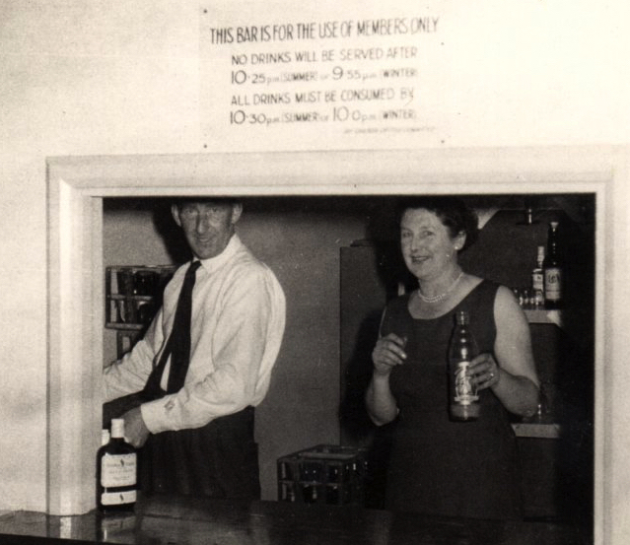

Norah & Fred behind the bar in the early 1950’s

Fred also loved cricket and played regularly when he was younger.

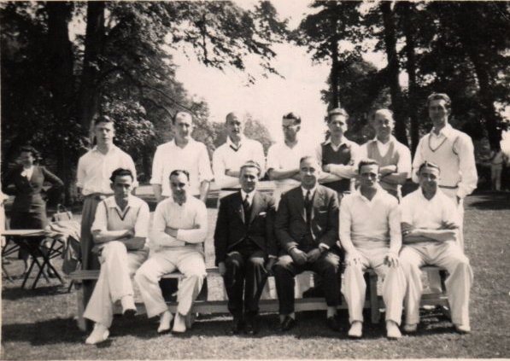

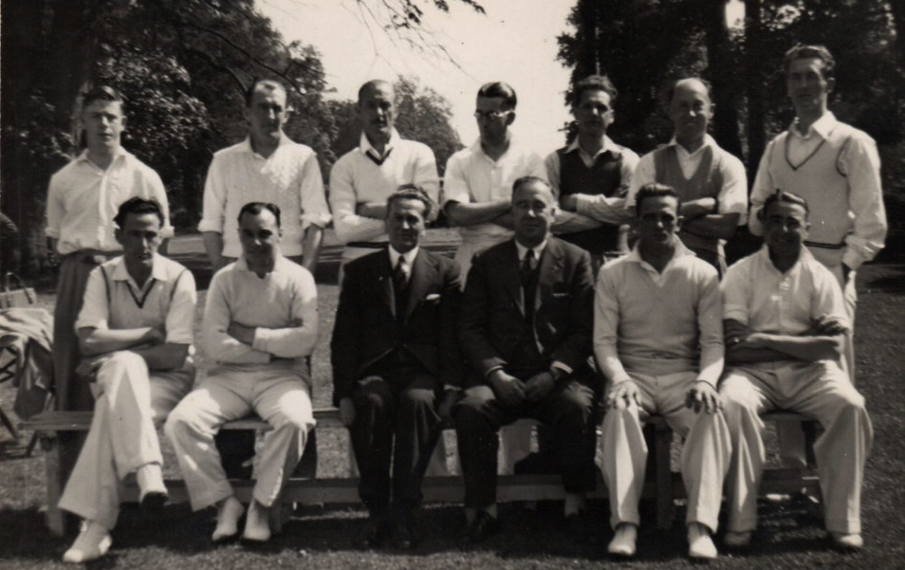

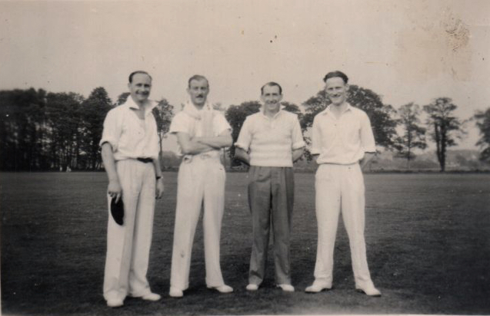

Fred, second from Left

He also loved horseracing and once got a Yankee bet up, winning a goodly sum!

After Fred retired he worked occasionally doing the accounts for a local tailor. Also, he and Norah used to act as holiday relief sub-postmasters for rural Post Office’s. Norah worked part time as receptionist in doctor’s surgery

Though childless they both loved children and held open house for nieces, nephews and local children.

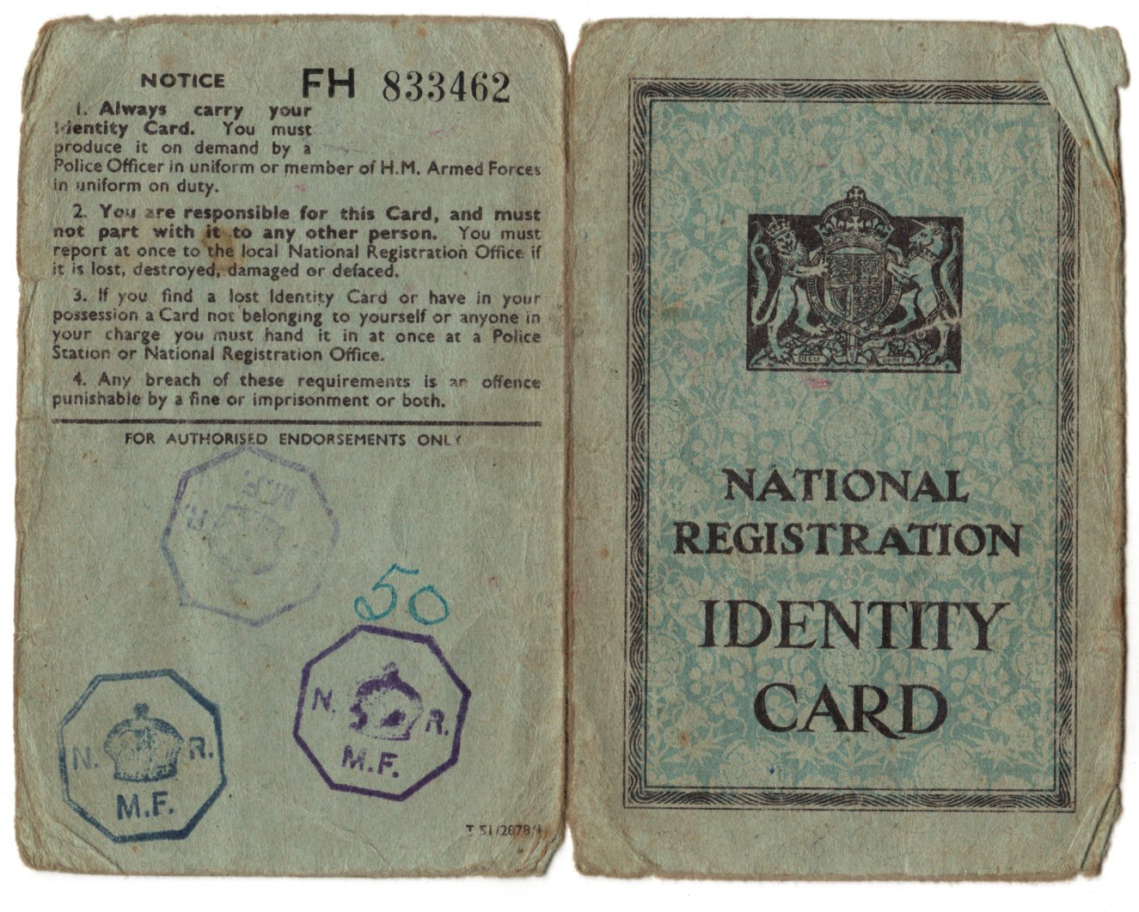
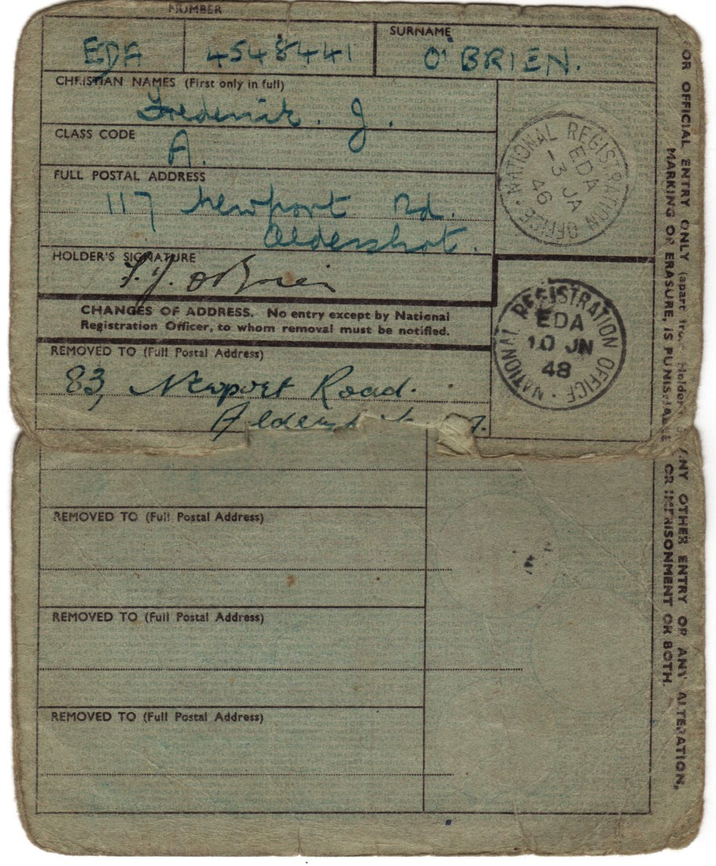
Fred’s ID Card issued in 1946

The National Registration Act 1939 was an Act of Parliament in the United Kingdom.
The initial National Registration Bill was introduced to Parliament as an emergency measure at the start of World War II. Royal assent given on 5 September 1939.
The Act established a National Register which began operating on 29 September 1939 (National Registration Day), a system of identity cards, and a requirement that they must be produced on demand or presented to a police station within 48 hours.
Every man, woman and child had to carry an identity (ID) card at all times and the cards would include the following information:
- Name
- Sex
- Age
- Occupation, profession, trade or employment
- Address; Marital status
- Membership of Naval, Military or Air Force Reserves or Auxiliary Forces or of Civil Defence Services or Reserves.
65,000 enumerators across the country delivered forms ahead of the chosen day. On 29 September 1939, householders were required to record details on the registration forms. On the following Sunday and Monday, the enumerators visited every householder, checked the form and there and then issued a completed identity card for each of the residents. All cards at this time were the same brown/buff colour.
Three main reasons for their introduction:
1. The major dislocation of the population caused by mobilisation and mass evacuation and the wartime need for complete manpower control and planning to maximise the efficiency of the war economy.
2. The likelihood of rationing (introduced from January 1940 onwards).
3. Population statistics. As the last census had been held in 1931, there was little accurate data on which to base vital planning decisions. The National Register was in fact an instant census and the National Registration Act closely resembles the 1920 Census Act in many ways.

On 21 February 1952, it no longer became necessary to carry an identity card. The National Registration Act of 1939 was repealed on 22 May 1952.

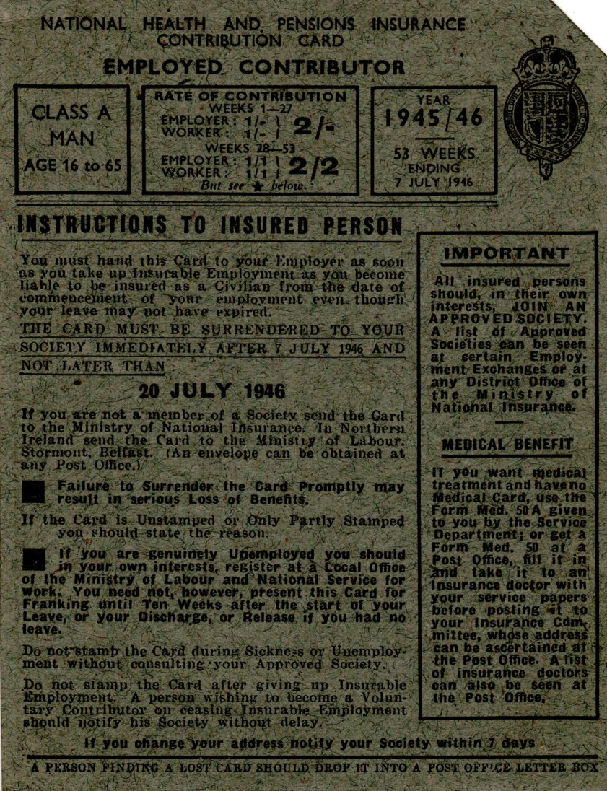 | 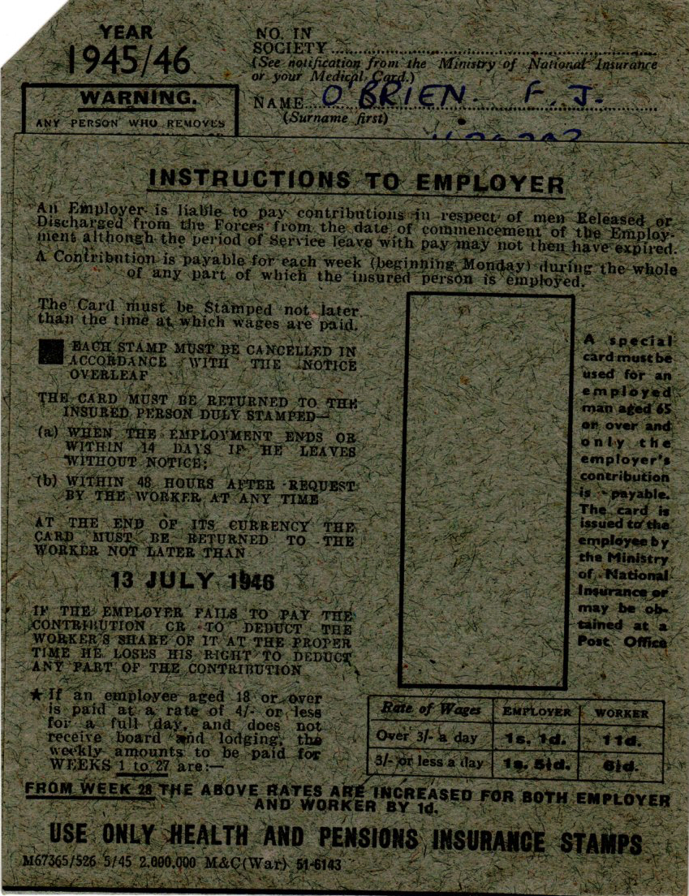
Fred’s National Insurance Card 1945/46  (not well used!)  The current system of National Insurance has its roots in the National Insurance Act 1911, which introduced the concept of benefits based on contributions paid by employed persons and their employer.  The chosen means of recording the contributions required the employer to buy special stamps from a Post Office and affix them to contribution cards.  The cards formed proof of entitlement to benefits and were given to the employee when the employment ended, leading to the loss of a job often being referred to as being given your cards, a phrase which endures to this day although the card itself no longer exists. | 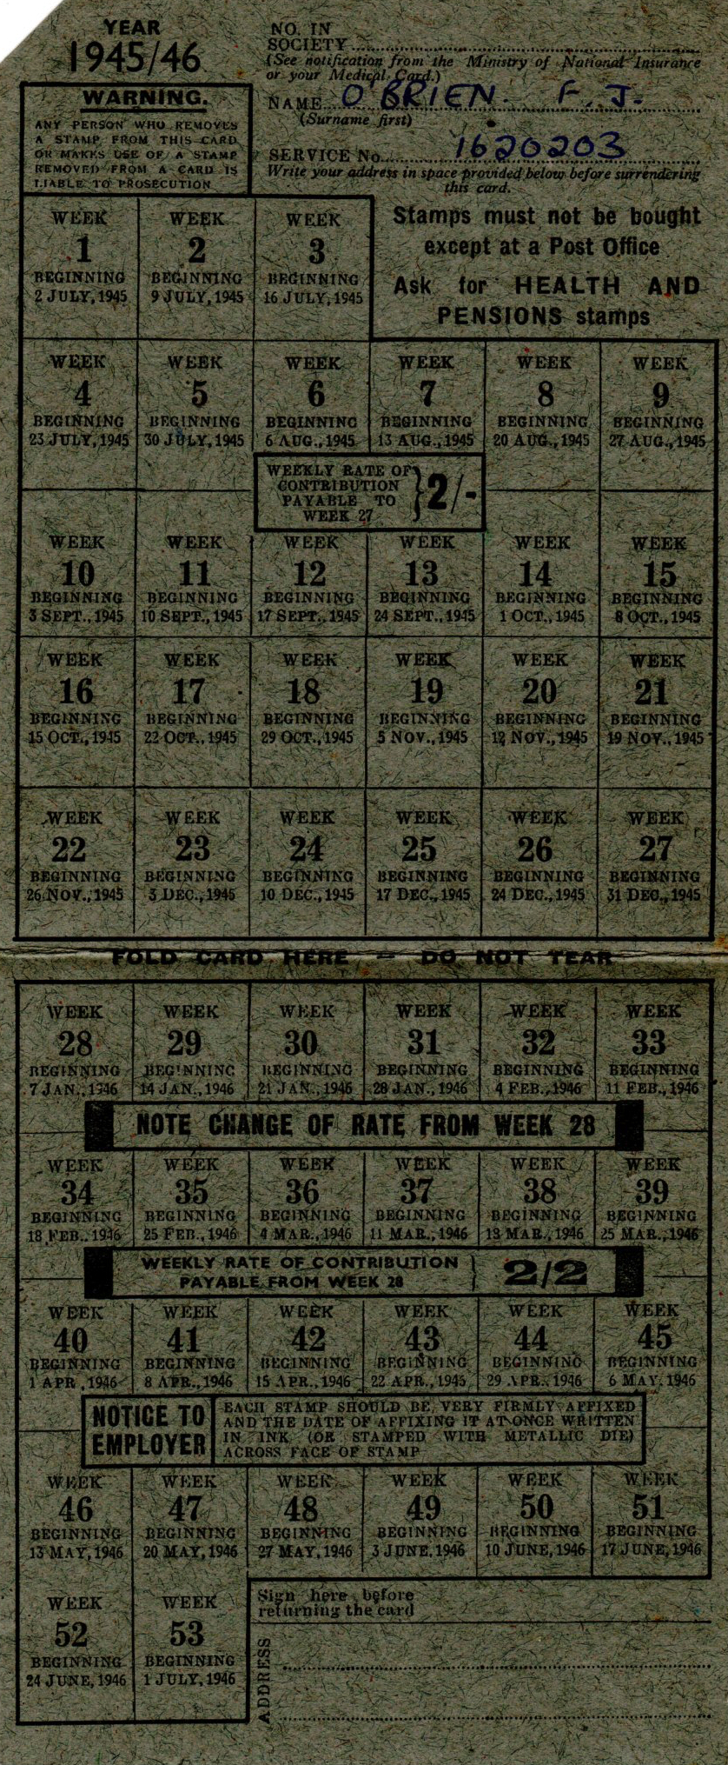

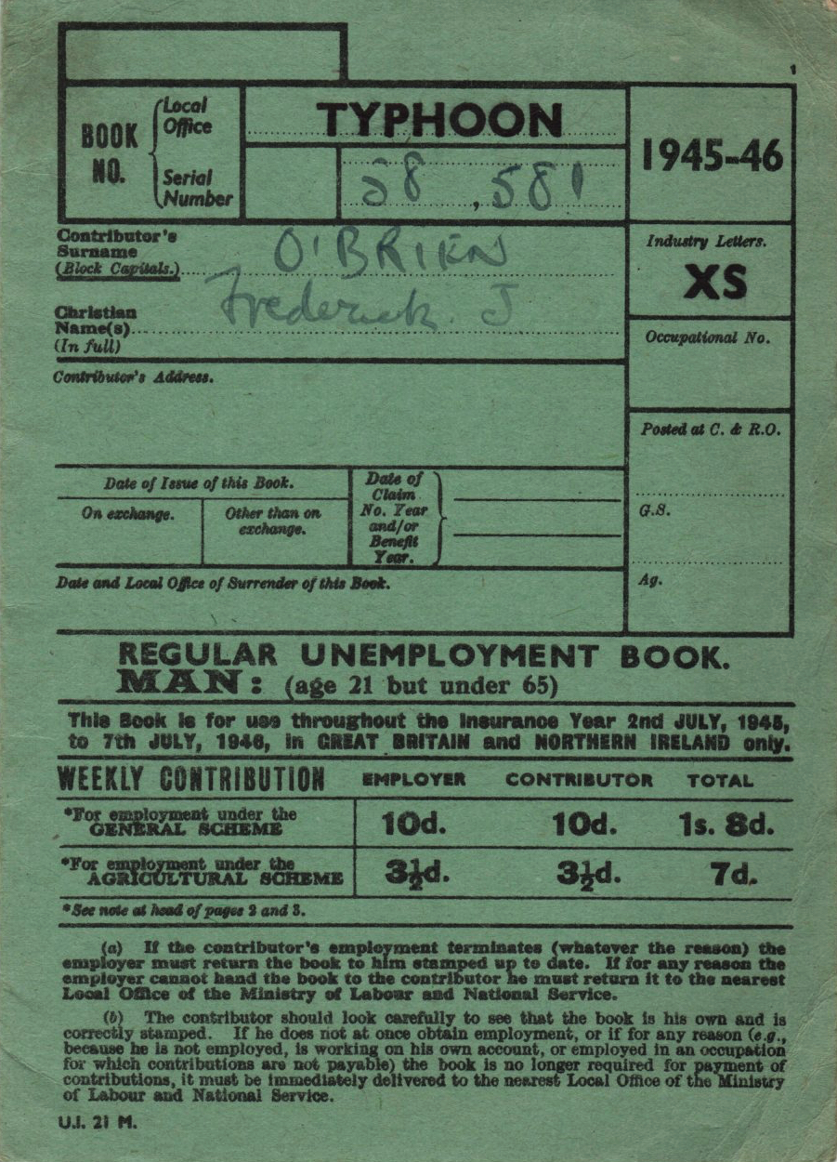 | 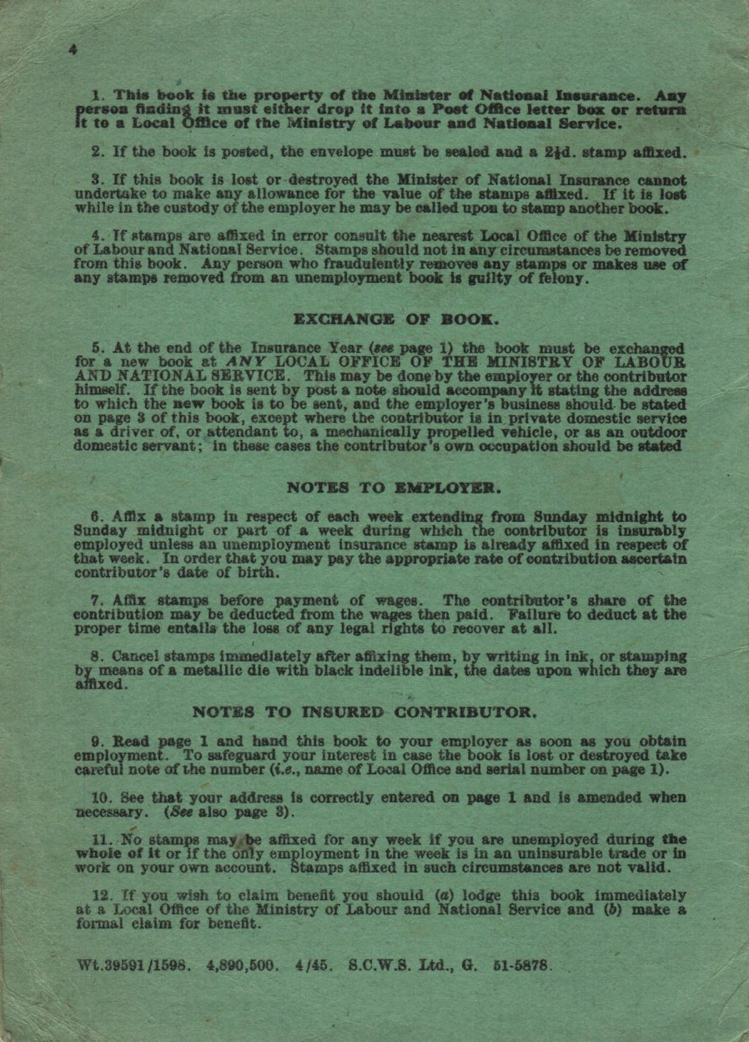

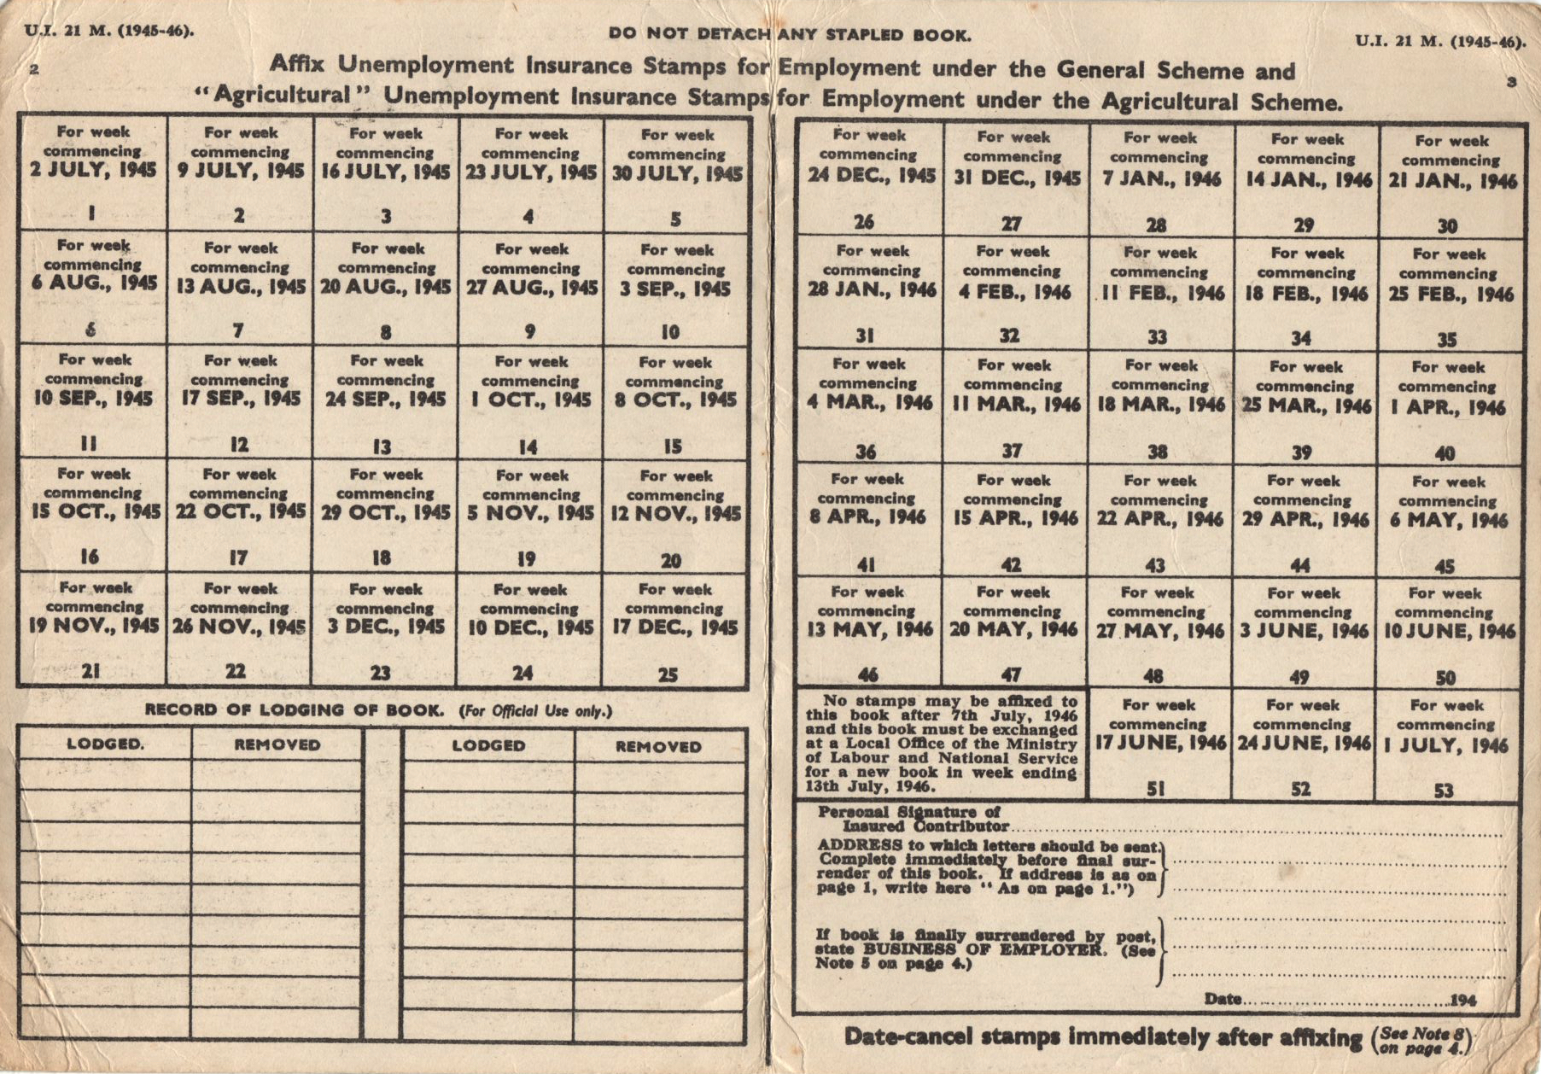

Fred’s Unemployment Book 1945/6

John Rust

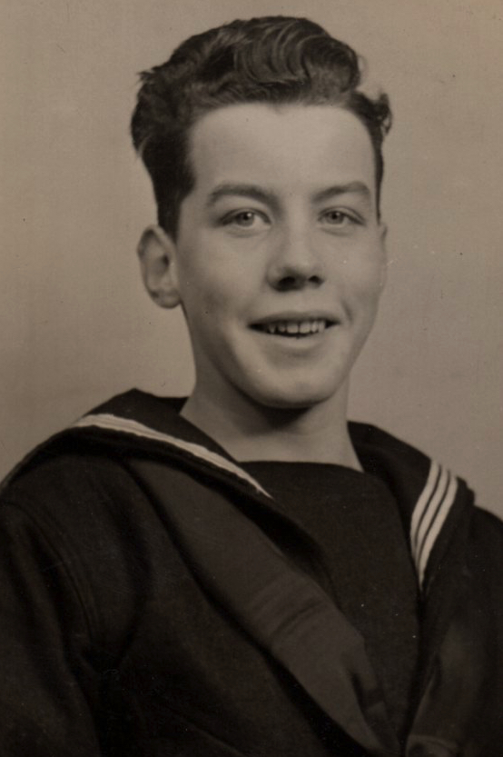 | 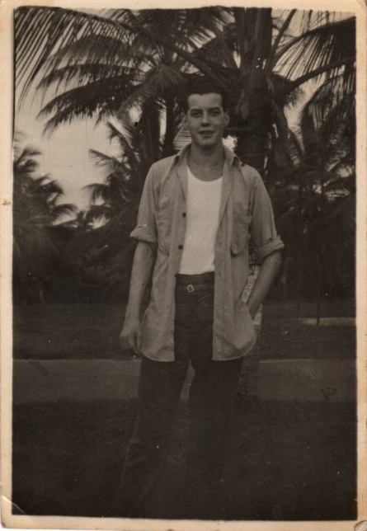

John Rust

John Rust came to live with Norah & Fred when his mother Lucy Elieen (Ellen) Rust (Fred's sister) died in 1935. He left after the War having fallen out with Fred when he returned from the RAF; he was not heard of again and his fate remains unknown.

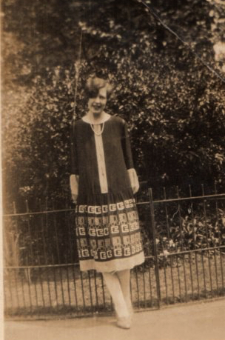

Ellen Rust

